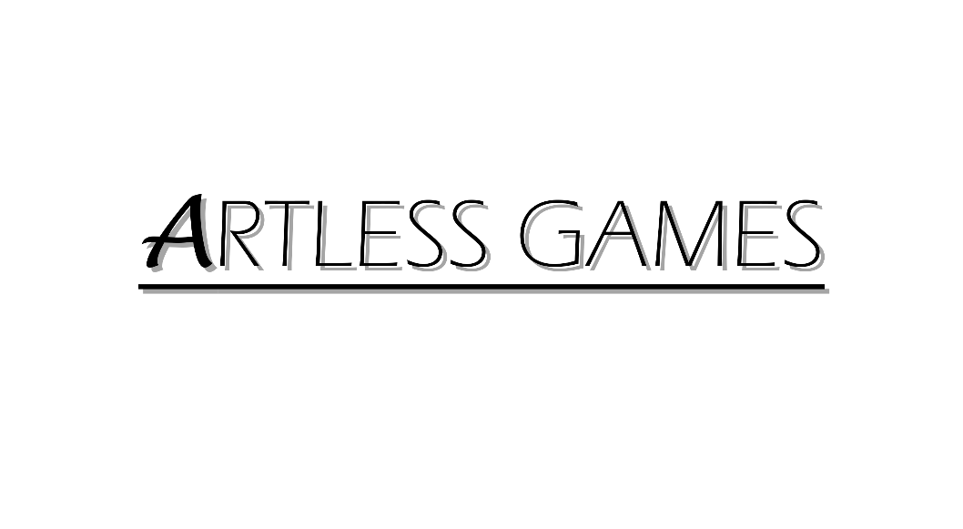

**COLD NITES**

Alpha-2

**Audio Module Design Document**

Designed & Implemented by

Xiyang Chen

040995767

**Table of Contents**

1 Introduction 4

2 Design Goals 4

3 System Behavior 4

4 Logical View 5

4.1 High-Level Design (Architecture) 5

4.2 Mid-Level Design 6

4.3 Detailed Class Design 7

5 Process View 8

6 Use Case View 11

Change History

**Version:** 0.4

**Modifier:** Xiyang Chen

**Date:** 04/03/2021

**Description of Change:** Fail to merge the Obstacle Class

**Version:** 0.5

**Modifier:** Xiyang Chen

**Date:** 04/18/2021

**Description of Change:** Debuging the Audio Module

# Introduction

Cold Nites is a Grid-style turn-based game. The player must strategically navigate the level to survive the cold night, protecting the boy from all the city's mischievous elements. And there are always multiple ways to solve the puzzles along the way.

This document describes the Audio module’s architecture and design for the Cold Nites from the ArtLess Studio application being developed for GAM1528 project. The Cold Nites is a turn-based puzzle game.

The purpose of this document is to describe the architecture and design of the Cold Nites application in a way that addresses the interests and concerns of all major stakeholders. For this application, the major stakeholders are:

* **Programmers** – The pickup function is essential to both gameplay and game mechanism.
* **Project Manager** – All the tasks during the group meetings were assigned with everyone's and the Project Manager's agreement. This module and the code implementation are highly related to the other modules. The PM (Project Manager) is in charge of the connection and potential influence among the programmers in the team.

# Design Goals

The design priorities for the Audio are:

* The design should minimize complexity and development effort.
* The design should provide sound effect to the game.

# System Behavior

The system provides sound effect to the game and UI.

# Logical View

The logical view describes the high-level architecture for the entire game from all the core classes to high-level relations and interactions between them with a flow chart making it easy to read and understand.

The detail will be demonstrated in UML diagram.

## High-Level Design (Architecture of the Entire system)

The primary features for the Alpha 1 release:

1. TileMap - TileMap provides the grid-based behaviour for the game and will facilitate the event system, based on the actor present on the Tiles.

2. Turn-Based System - This provides the turn-based aspect for the game. It is responsible for maintaining the turn order for all the world elements(actors) and the player.

3. Base Grid Classes - These classes work as a foundation class for all the actors/characters spawned in the game. These classes are closely integrated with handling the TileMap(Grid-Base) Behaviour of the game.

4. Player Character - Player is a controllable character that inherits from BaseGridCharacter, which takes user inputs to perform appropriate moves.

5. Inventory System - The pickup function helps the player grab the items on the map. Inventory stores the items for the corresponding actor and will allow the player easy access to any collectible throughout the game, and it also assists in equipping the stored items.

6. Menu Interface - The Menu Interface will be responsible for Main Menu and Pause Menu with which the player can interact.

The primary features for the Alpha 2 release:

7. AI System - AI System is responsible for various enemy types in the game. The AI System allows the ease of creation using the single BaseAI class and Behaviour Tree Task Nodes.

8. Event System –

9. Camera Manager - Camera Manager is responsible for handling the game view. It provides the functionality of spawning the camera and handles the switching between the desired cameras.

10. Level Management System –

11. Sound – Provide the sound effect to game movement and UI

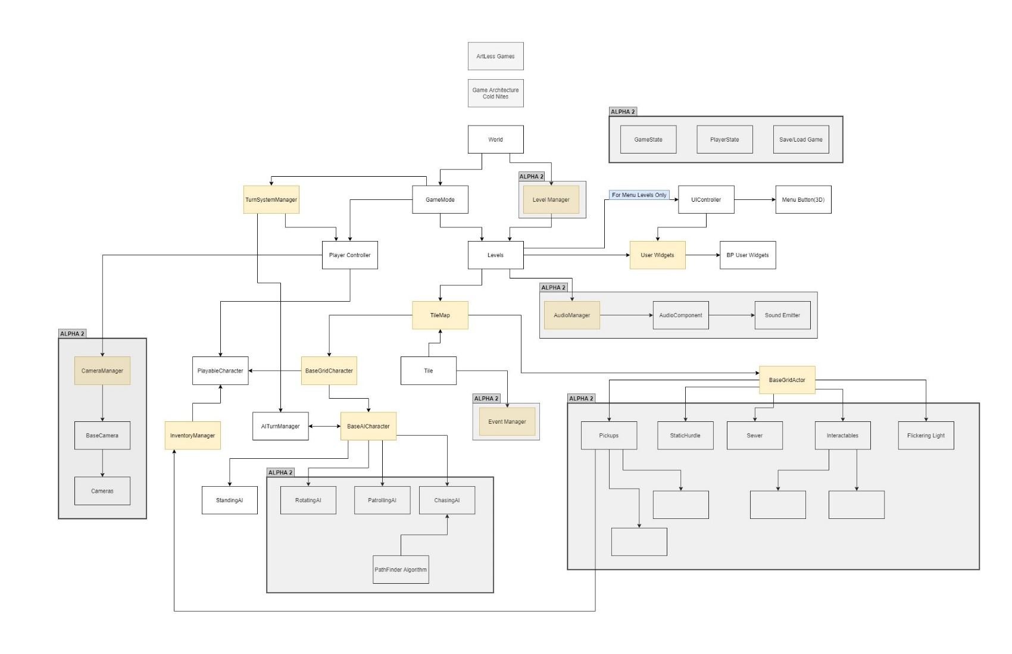

## Mid-Level Design of Audio Component

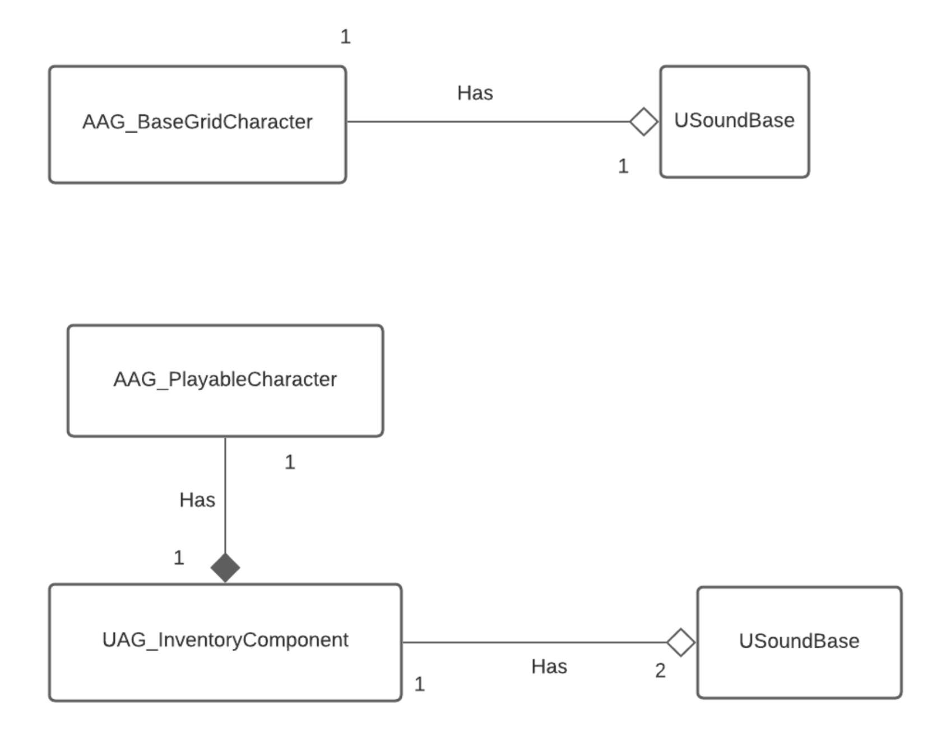

## Detailed Class Design of Inventory

# Process View

When any Character walks, there will be a walk sound played background. For the player that picks up, there will be sound effect when picking up, and sound effect for scrolling the inventory.

# 

# 6 Use Case View

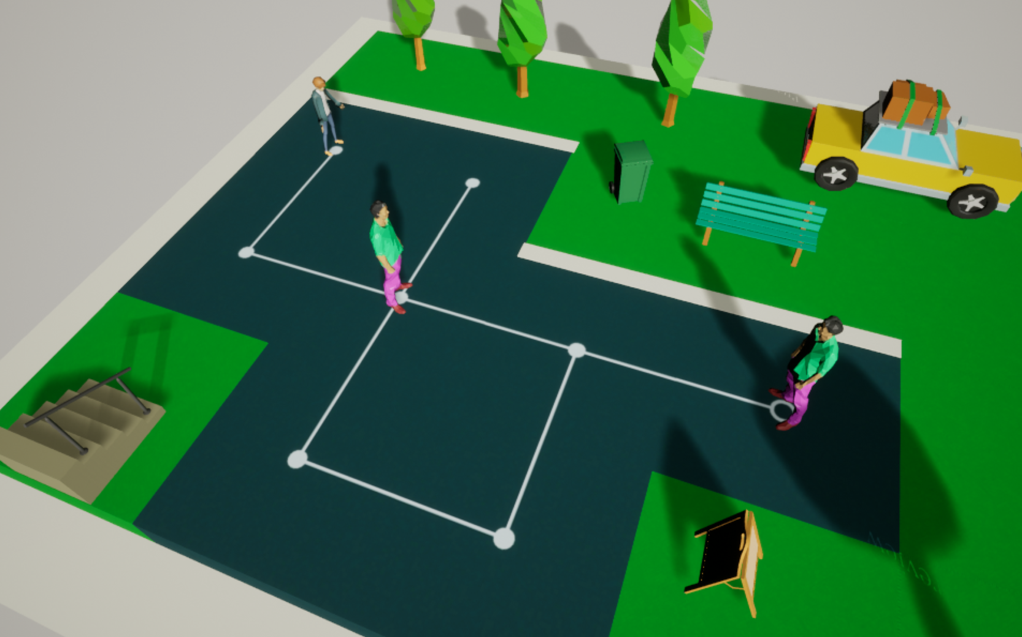

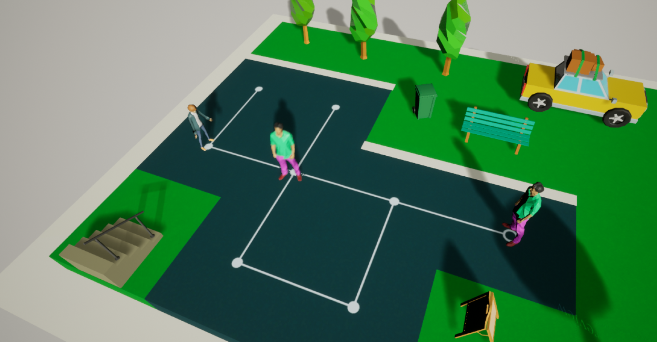

When move to next step, there will be walking sound played by the SoundBase.

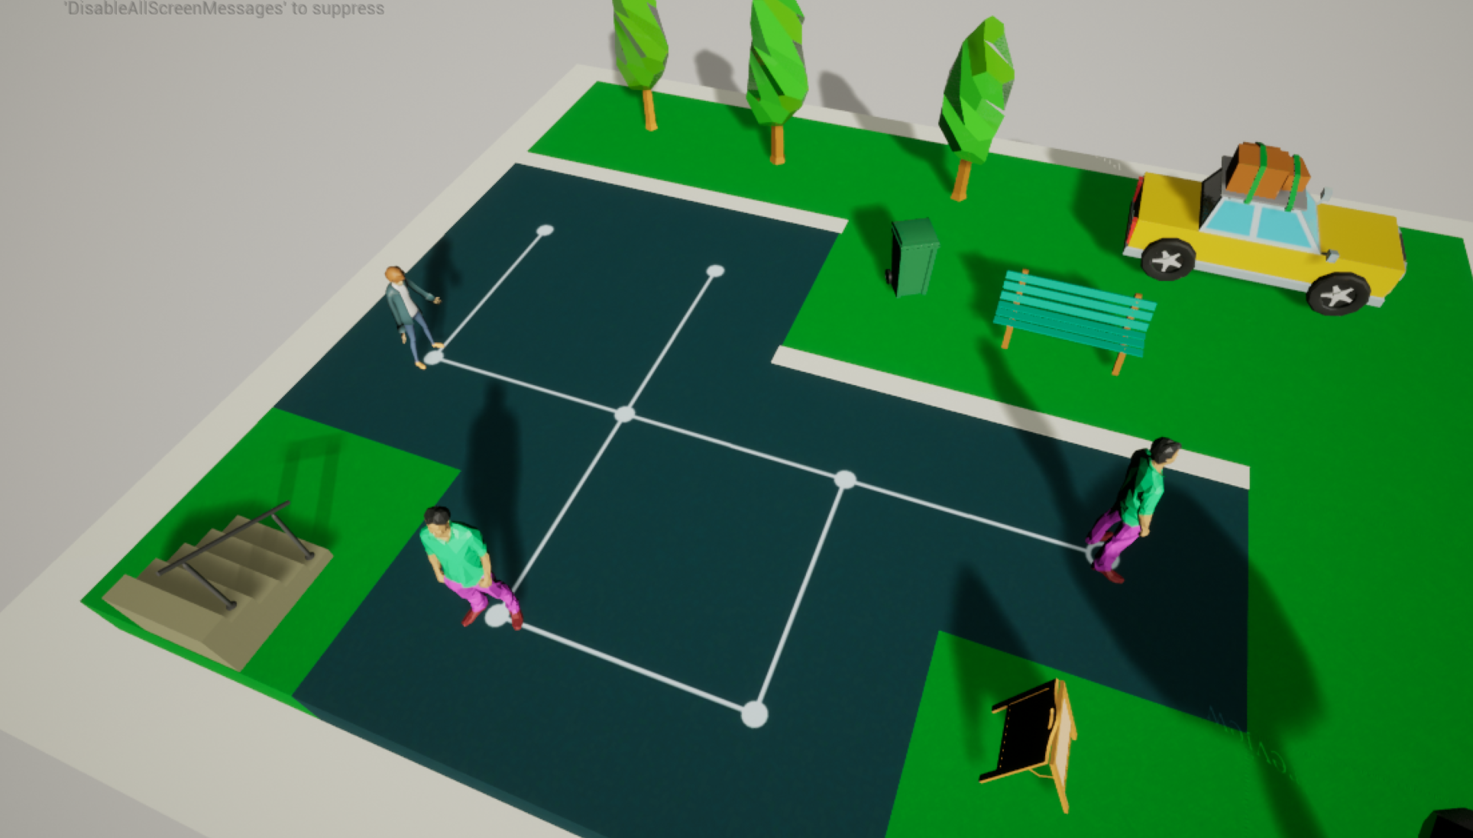

When AI moves, there is also walking sound effect.

When Picking up the pickupActors (in AG_ColdNites_Level_6), there will be sound effect:

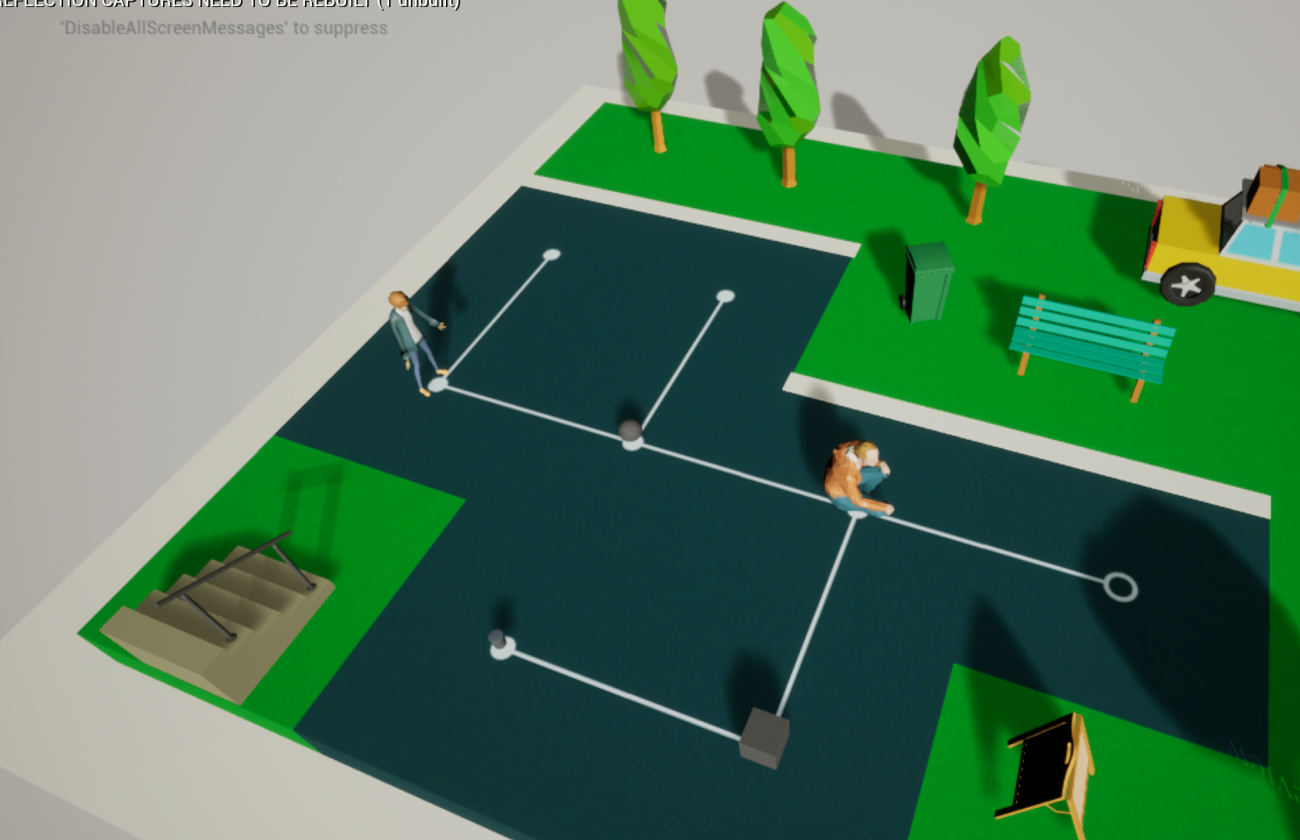

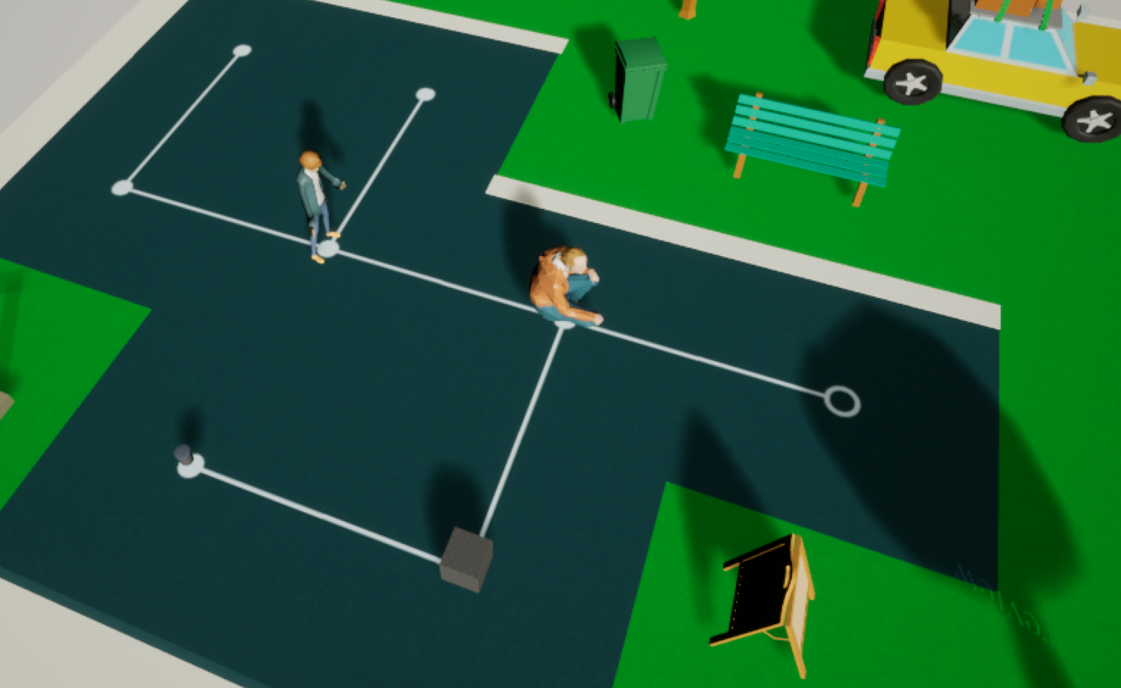

There will also be sound effect when switching the collections in inventory(pressing Pageup and Pagedown keys)

